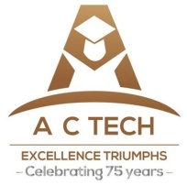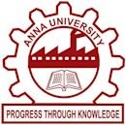 **ANNA UNIVERSITY**

**NAAN MUDHALVAN – GUIDED PROJECT**

**TRANSPARENT EDUCATION DATA MANAGEMENT**

**Project Design Phase-II**

**Data Flow Diagram & User Stories**

|  |  |
| --- | --- |
| Date | 31 october 2023 |
| Team ID | 1. DHARUN M -  0270CBCD3358D93874A40B917EEC65EC 2. DIVYA DHARSHINI -  087EE4C0342F965ADBA46 49B908C2642 3. ELASUKUMARAN E - 23556780714CDCFB5B84BF4E9269022A 4. GOWTHAM R -  0BF3F06AC53C10E89F446EF2C7C77B3C   VYSHNAVI M - 4284E4FD1316A93BEA54DC B745B8F87F |
| Project Name | BLOCKCHAIN POWERED LIBRARY MANAGEMENT |

**Data Flow Diagram :**

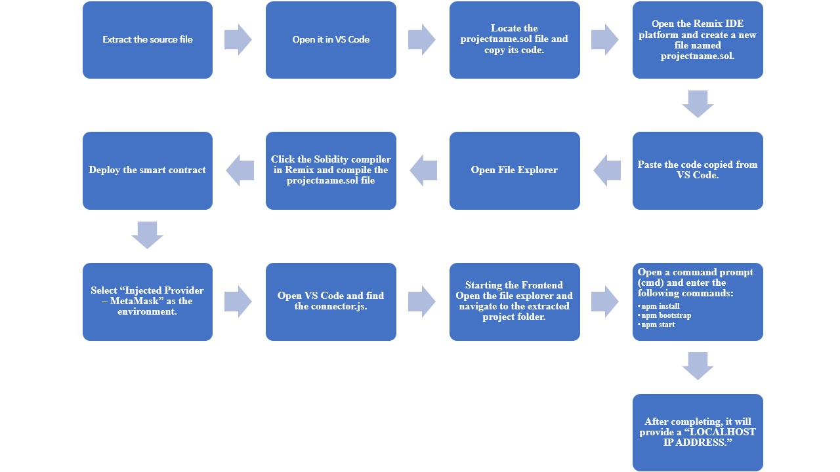

Blockchain is a new and reliable technology that helps with security, preservation and reliability of data. Libraries are change agents of the 21st century and are implementing new technologies to provide maximal information in minimal time. Blockchain technology can be used to solve different problems in the library field with proper usages for storing information in a distributed tamper-resistant setting. Blockchain in library settings can be used to gather, preserve and share authoritative information devoid of many technological hurdles. Some challenges such as finance, technical and security issues are troubling factors, but proper training, support from decision makers and technical skills regarding this technology will pave the way for library practitioners.

**Characteristic of blockchain technologies:**

Some key characteristic of blockchain technologies are listed as follows:

* Increased capacity: Blockchain technology can increase the capacity of an entire network. One such example is the supercomputer created by Stanford University used for medical research.
* Better security: Blockchain technology offers better security as it provides for a network of numerous computer nodes that can be used for networking transactions .
* Immutability: Blockchain uses immutable ledgers, and all databases require trust of a third party to keep them secure from hackers. Blockchain applications, such as Bitcoin, maintain the ledger in a never-ending state of forward momentum.
* Faster settlement: Blockchain technology relies on faster speeds and saves time for institutions and consumers. One example from banking is that blockchain makes money transfer fast and convenient.
* Decentralized System: Blockchain technology offers a decentralized system that stores the assets in a network and can be accessed via the internet. The asset may be a contract or document of importance. The manager of blockchain technology has control over the accounts of individuals and can transfer anything to anyone. This technology is proving to be an effective tool for decentralizing the web.
* Minting: Blockchain technology involves minting a problem in several ways. Proof of work is one approach guaranteeing an individual is engaged in a significant amount of computation work.

**USER STORIES :**

User stories are a useful way to outline the functional requirements of your project from the perspective of end-users and stakeholders.

* As an Administrator, I want user Account Management, create and manage user accounts, assign roles, and reset passwords as needed. Disable or delete user accounts when necessary.
* As an Educator, I want data entry and management, enter student grades, attendance records, and assessment results into the system. View and edit student information and performance data.
* As a Student, I want to access to Personal Data, view my own grades, attendance records, and assessment results. Access any relevant announcements or assignments from educators.
* As a Parent, I want to access to Child’s Data, view my child’s grades, attendance records, and assessment results. Receive notifications and updates on my child’s performance.